Finding Images for Presentations, Web Pages, and Blogs
Creative Commons
“Creative Commons is a nonprofit organization that enables the sharing and use of creativity and knowledge through free legal tools.
“Our free, easy-to-use copyright licenses provide a simple, standardized way to give the public permission to share and use your creative work — on conditions of your choice. CC licenses let you easily change your copyright terms from the default of “all rights reserved” to “some rights reserved.”
“Creative Commons licenses are not an alternative to copyright. They work alongside copyright and enable you to modify your copyright terms to best suit your needs.”
Characteristics of the Various Creative Commons Licenses
 | Attribution | You must credit the creator.
 | ShareAlike | When you license your material, you need to use the same Creative Commons license as the original material you used.
 | NoDerivs | You cannot change the original.
 | NonCommerical | This material cannot be used for commercial use.

Public Domain
Works in the public domain do not have any copyright restrictions. They can be in the public domain for one of three reasons:
- The material is not copyrightable (e.g., titles, names, slogans, government works).
- The creator chose to put the material in the public domain instead of copyrighting it.
- The copyright has expired (e.g., Shakespeare’s plays are no longer copyrighted).

Finding Images in the Public Domain
Pixabay: https://pixabay.com/
The Commons: https://www.flickr.com/commons
MorgueFile: www.morguefile.com
Smithsonian: https://www.flickr.com/photos/smithsonian
Public Domain Images from the New York Times (https://goo.gl/kReu7d)
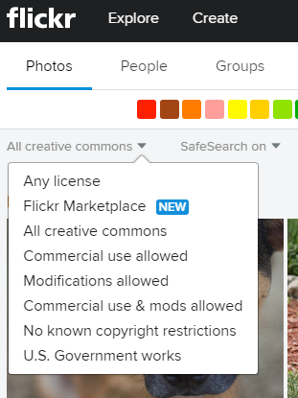
Finding Images with Creative Commons Licenses
Photos for Class: http://www.photosforclass.com/
WorldImages Kiosk from CSU: http://worldimages.sjsu.edu
Flickr.com – be sure to set the License to one of the creative
commons options
Compfight.com is a search engine for Flickr. Again, be sure
to switch from Any license to Creative Commons.
Note that many of these sources put images for sale at the top
of the results.
