Jay ’64 and Cheri ’67 Nugent
Met at Simpson in the fall of 1963. Married for 58 years June 16, 2026. Enjoy keeping up with other Simpson couples over the years!
Jim and Pam Robinson
Rich and Helen Pemble
Denny and Kaye Price
Erwin and Jan Pellant
Jan and Phyllis Wilson
Don and Karen Drake
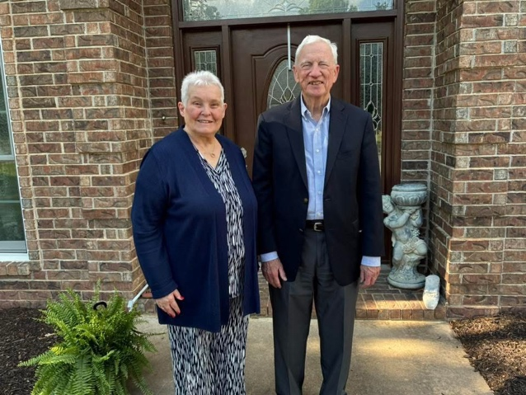

Steve & Kathy Mason
Will be married 49 years in August. We celebrated our 40th at Wrigley Field.
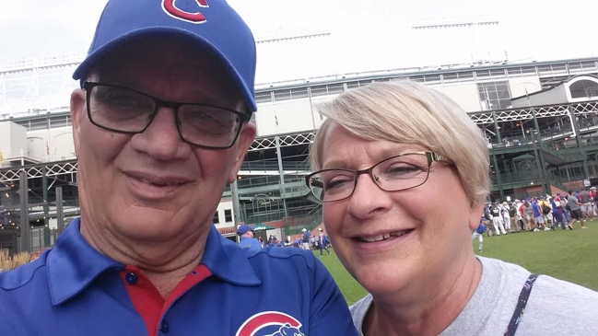

Kurt & Lyssa Hoffmann ‘00
Met before Simpson, married 26 years!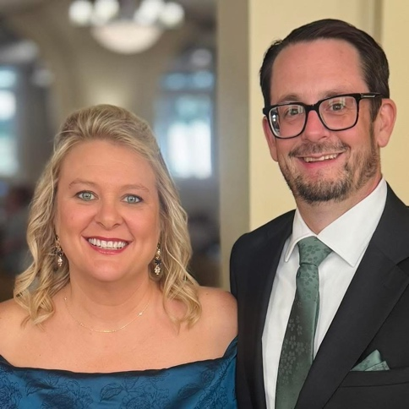
Shawn '07 and Susan '08 Linnell
Married in 2010! 2 Masters, 3 kids, many moves, and 20+ years together makes a full life that all started with a sideways glance from a table across the room in Pfiffer Dining Hall.
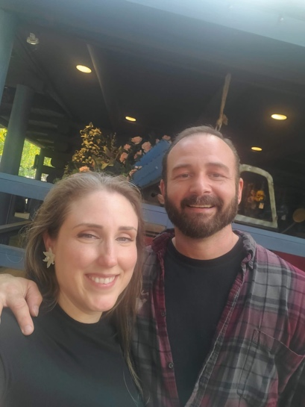

Garrett & Kathryn (Heiar) Wirtz
Met at Simpson as freshmen in 2006! Married in 2012.
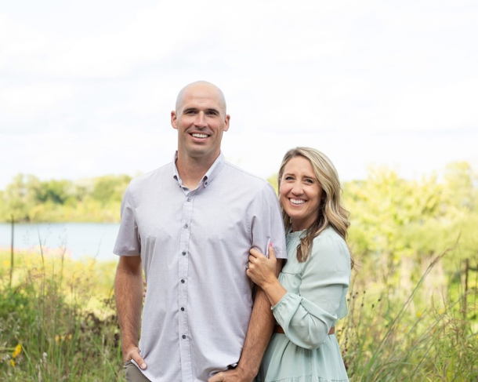

Jesse '03 & Meghan '04 Von Behren
Married 20 years, 9/4/05!
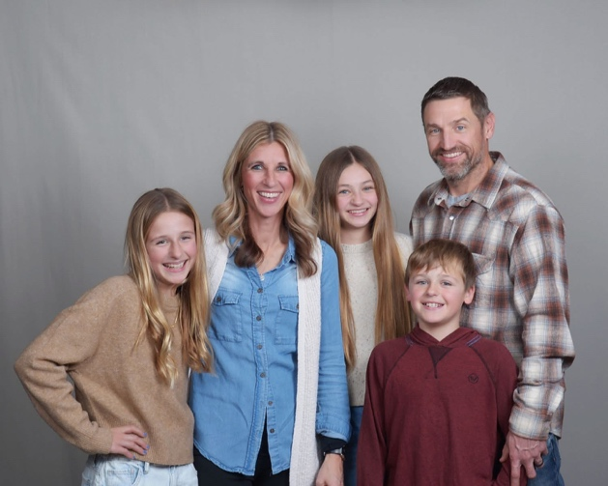
Shawn Schossow (Master’s Class of ‘21) and Korie Torres ‘22
Met 2019, together since 2020!
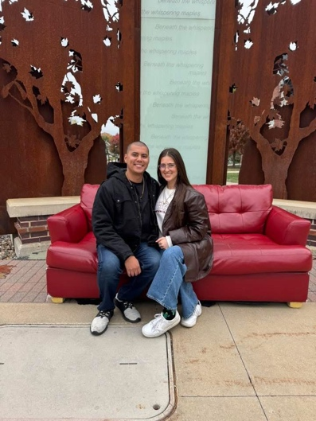

Drew and Kaylee Roen ‘19
Together 10 years and married 4 years.
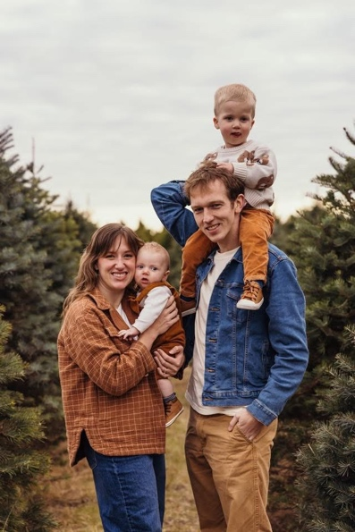

Jason and Teri Stolte
Married in Smith Chapel 1994, still happily married for 31 years.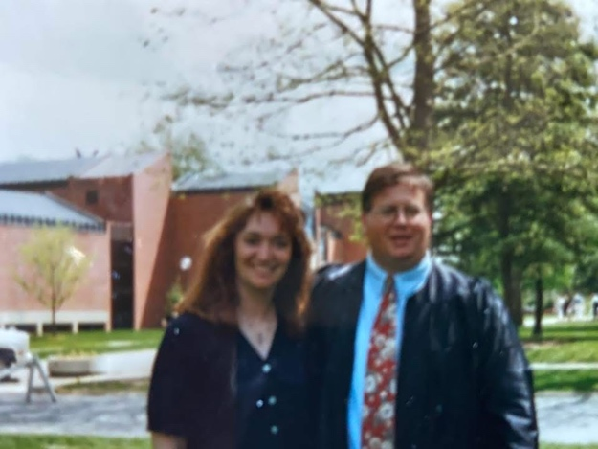
Caleb and Beth Grose
I followed in my parents footsteps (Jason and Teri Stolte) and went to Simpson and married my own Simpson Grad!
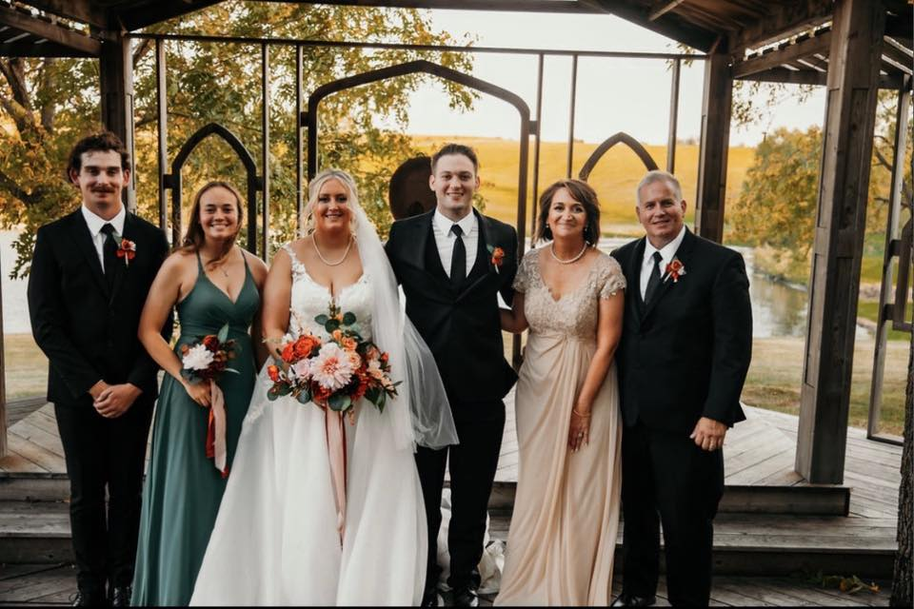

Kellen Fitch & Corinne Thomas ‘21
Class of 2021! Getting married on April 29th!
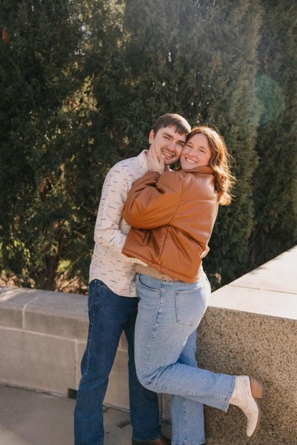

Dustin and Taylor Teays ‘19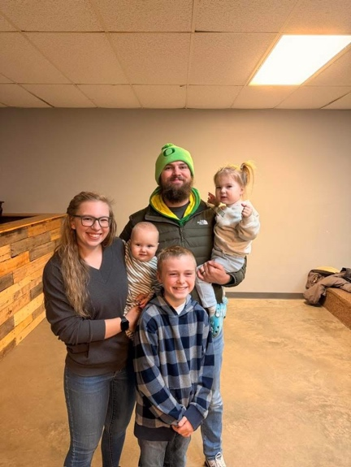
Randy Paulson and Maria Kosovich ‘19
Just celebrated our 9th anniversary!
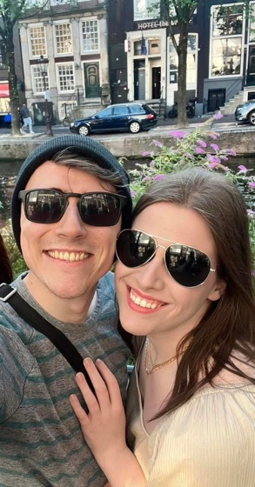

Rachel and Keegan Lamparek ‘19
Met in 2016, married at Smith Chapel in 2022
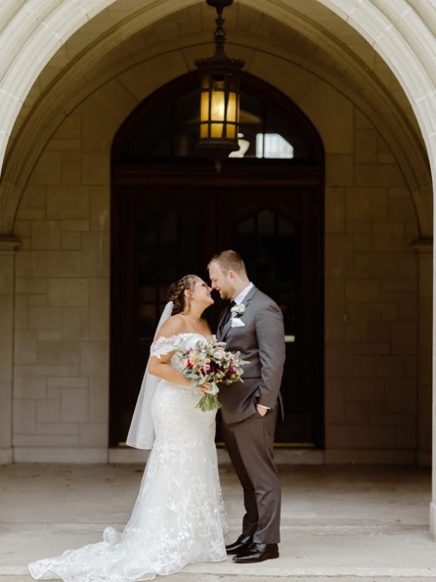

Jared Campbell ‘21 and Will Exline ’22
Together 7 years!
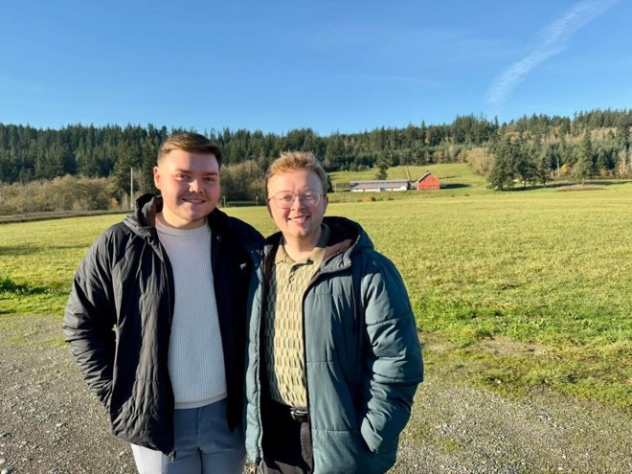
Austin and Janey Stoelk ‘19
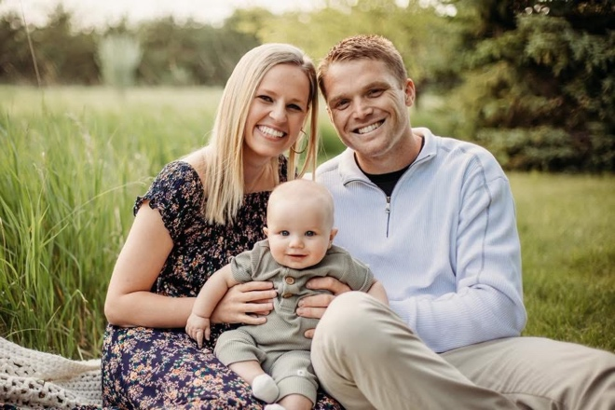

Mark and Mackenzie Clayton Becker ‘19
Married in 2020!
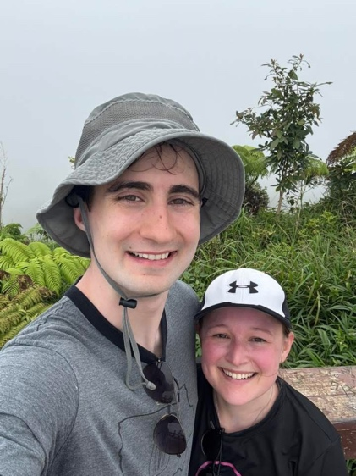

Scott and Logan Oderio ‘21
Together since 2019 and married since 2024.
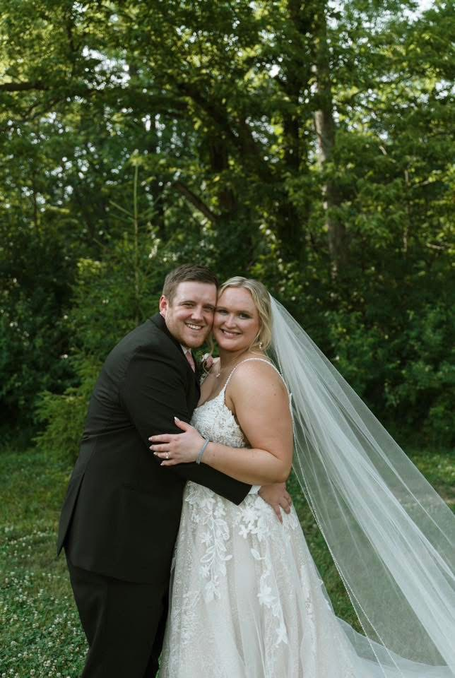
Te'Ariea Griffin ’15 and Victoria Kramer ‘16
11 years together, married 5 years!
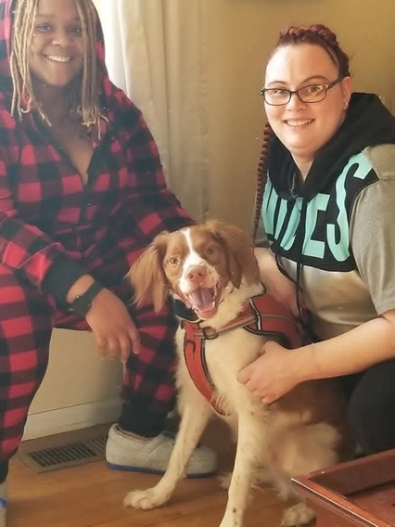

Annie and Jeb Burt ‘99
Married in Smith Chapel 27 years ago.
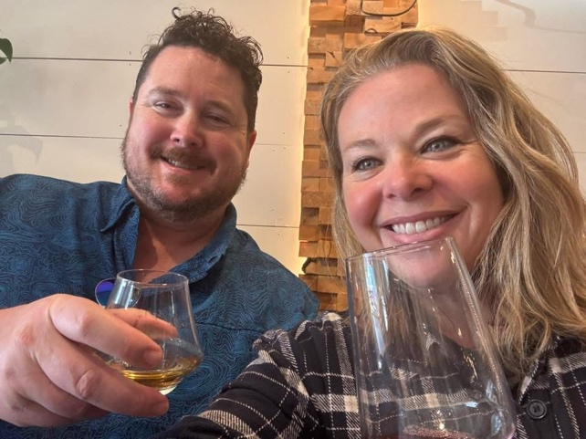

Nate and Erin Ruhland (Palmer) ‘07
Married 15 years this May.

Aaron and Tricia Case Mahan ‘97
Married 28 years!
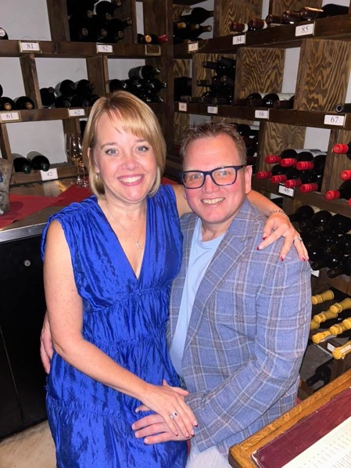

Jamie ’15 and Korey Kreimeyer ‘14
Married 8 years this June!
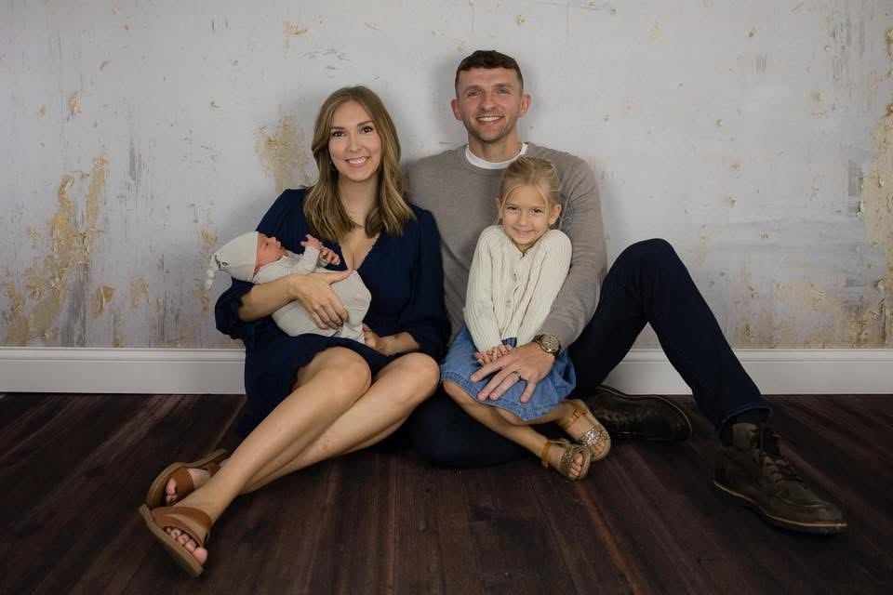

Clint and Mallory Wallace ‘07
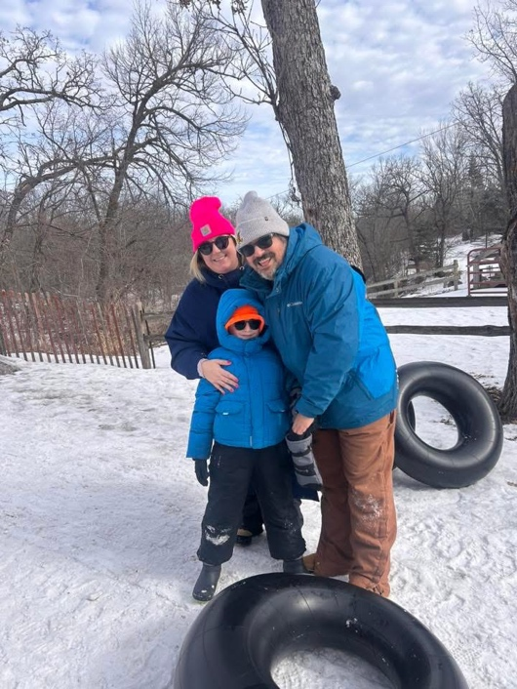
Jon and Mara Bailey '06
Married for 20 years this summer!
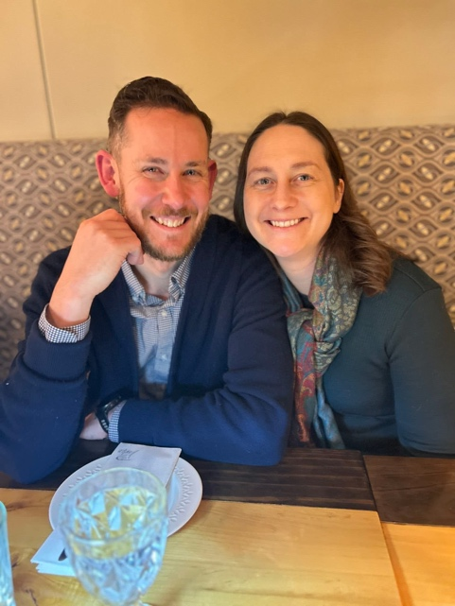

Tiffany ‘06 & Ryan ‘05
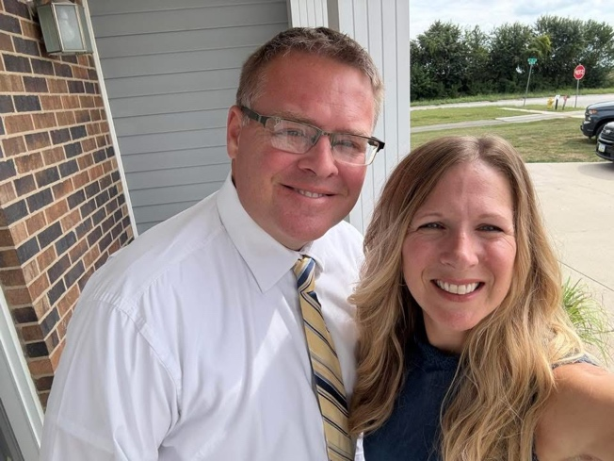

Brandon Geise ‘96 and Molly McGuire ‘95
Married for 28 years!
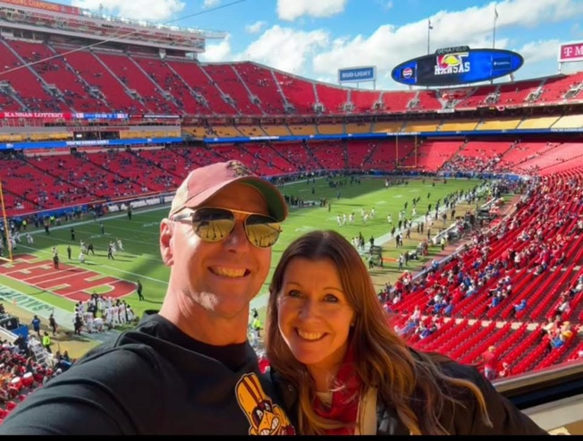

Sherwin ’82 and LeeAnn VanSickle Back ‘81
Married 44 years in August!
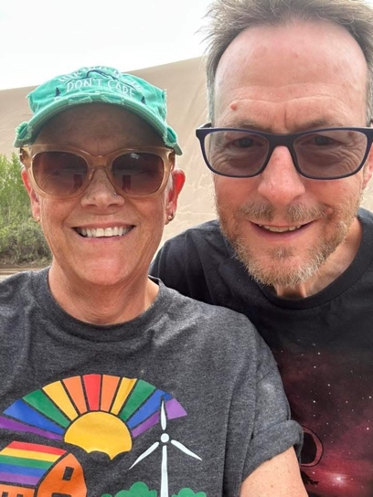

Stefon ‘12 and Natalie Brown ‘13
Married 8.5 years, together 14 years!
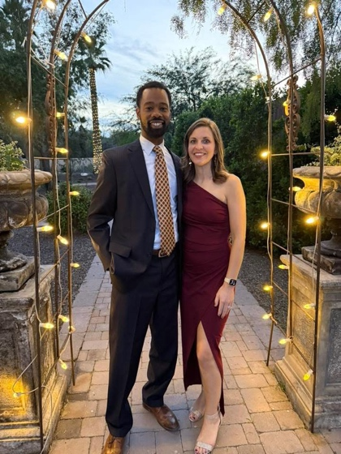

Dan Wood and Laurie Sankey-Wood ‘85
Married at Smith Chapel on January 3, 1987!
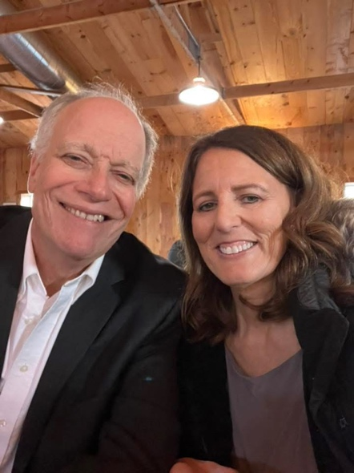
Julie Plummer ‘95 and Scott Patterson ‘94 Married at Smith Chapel in 1997
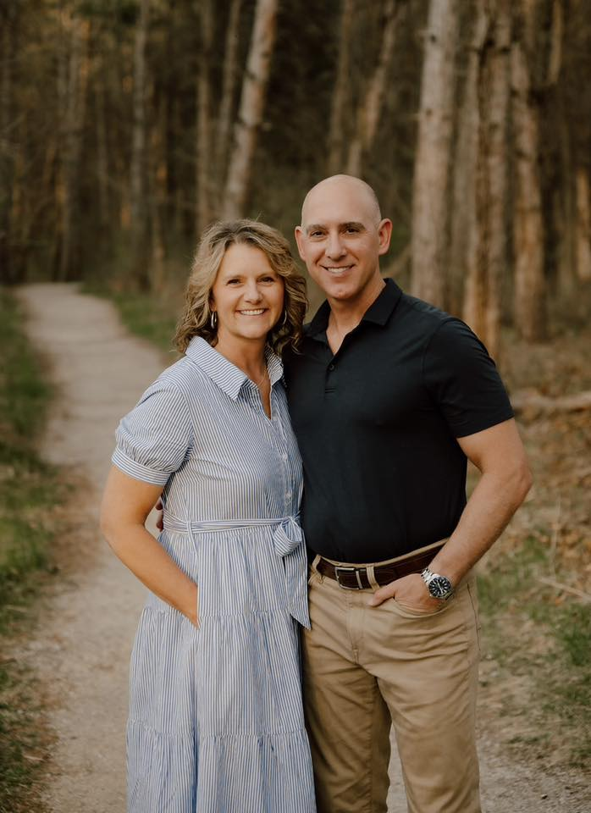

Braden ‘18 and Haley Meints ‘17
Together for 10 years this year!
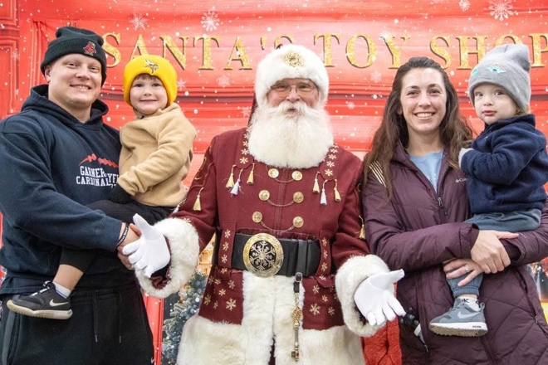

Carrie (Schroeder) Steffen (‘95) and Brian Steffen (‘94)
Married 30 years.
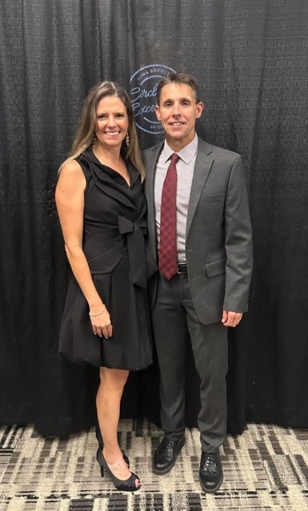
Rich and Elaine Forret
Married at Smith Chapel in June 1975!
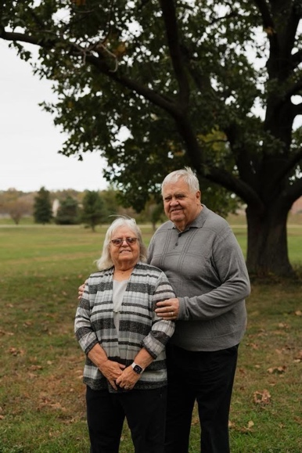

Kari ’03 and Ben ‘00
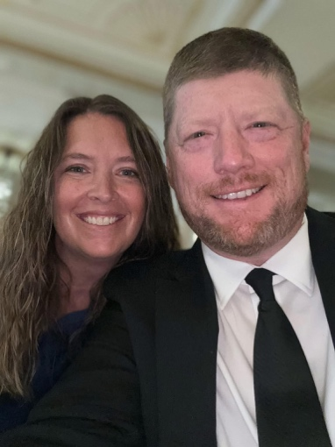

Roger ‘87 and Mary Beth Scott ‘90
Married 1989 in Smith Chapel plus Trey Scott 2016 and Bree Gaster 2016!
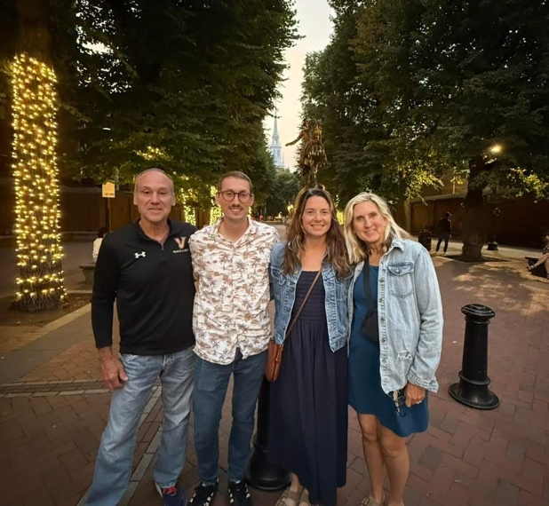
Aaron ’91 and Michelle ‘92
Met in 1989. Married at Smith Chapel in 1995. 4 great kids (1 is a Simpson alum - Class of 2020).1 granddaughter. Going on 31 years!
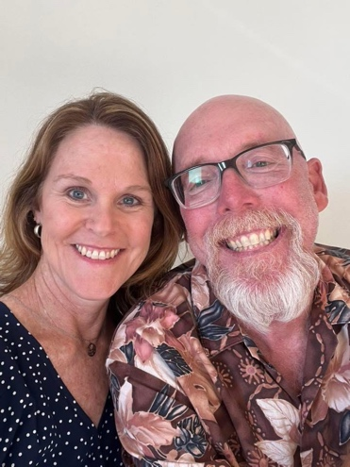

Chad Timm ‘95 and Andra (Loeffler) Timm ‘94
Married 30 years!
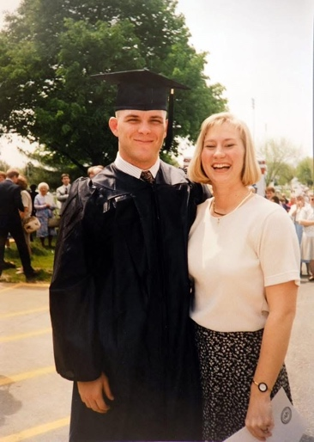

Leslie Midget Held ‘86 and Eric Held ‘88 Married 37 years. Met in Dunn Library. He finally got a date after he won over the TriDelta house mother first.
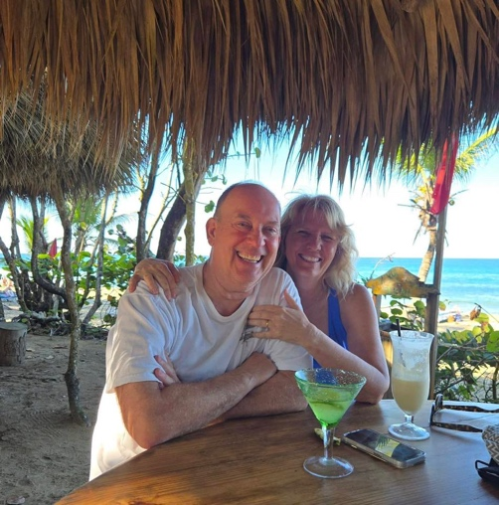
Dawn Van Ryswyk Goodale '87 and Chris Goodale
Married in Smith Chapel on July 18, 1987. It was 100 degrees!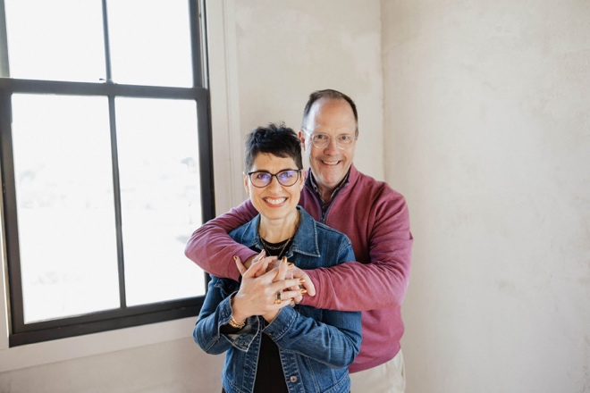

Dave ‘94 and Stacey Warren ‘01
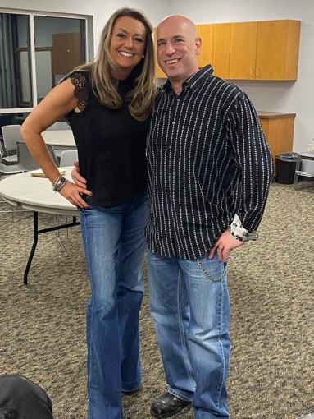

Angie Matheny Ortlund ‘97 and Ryan Ortlund ‘96
Married 30 years!
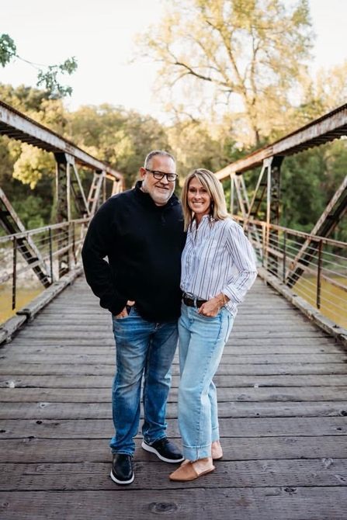
Brian Williams ‘15 and Tricia Ingram Williams ‘16
Met at Smith Chapel and then we were wed there ten years ago this year!
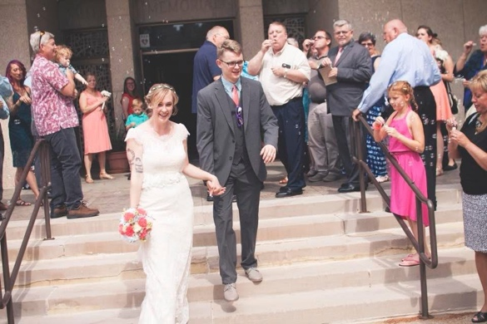

Dawn and Scott Schumacher ‘94
Married 26 years!
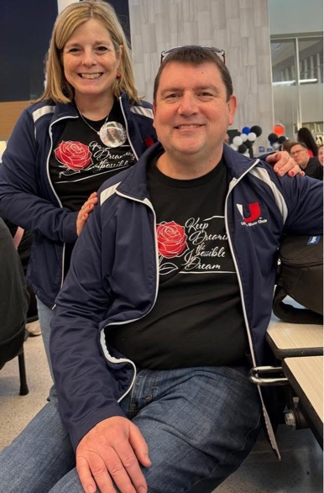

Kris and Alexa Rhode ‘16
Together 9 years and married 6!
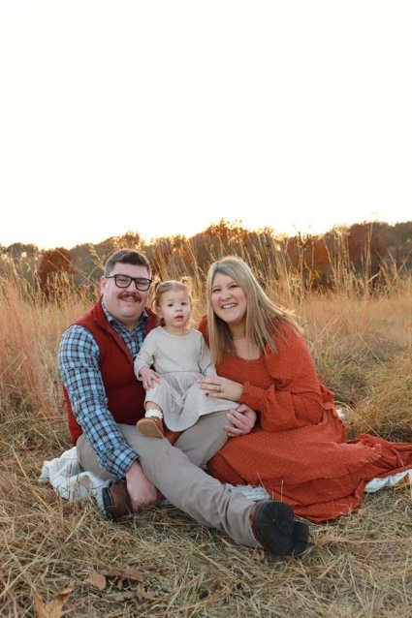
Erik Hall and Dani Musselman ‘16
11 years together, married 7.
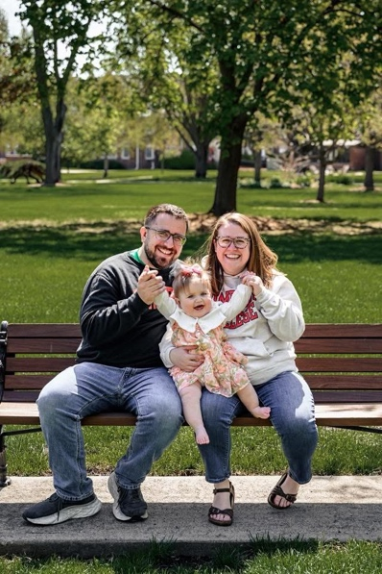

Kenzie and Jordan Bahl ‘16
Together 13 years, married for 7!
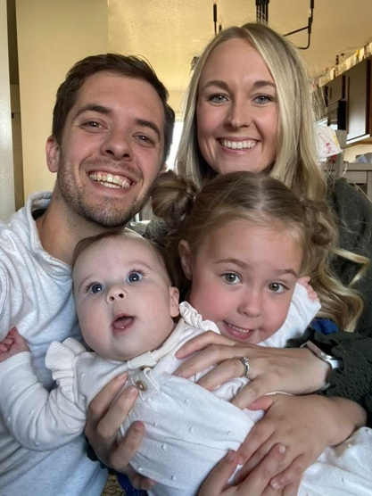

Josh and Tonya (Hegland) Cook ‘02
Met in 1999 at Simpson , Married in October 2003.
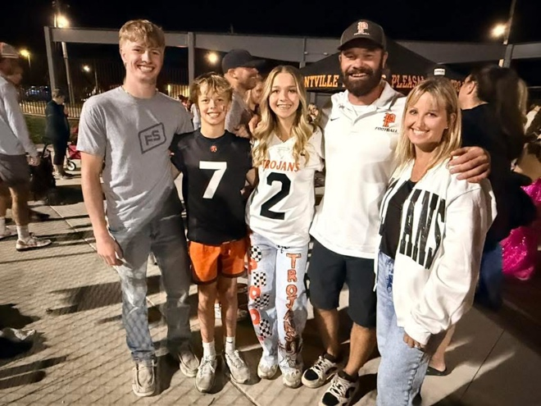
Matt ‘04 and Steph Zeller ‘06
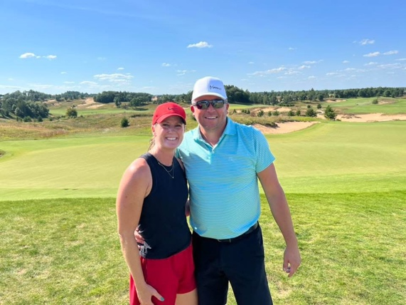

Jeff ’07 and Heather Travis ‘06
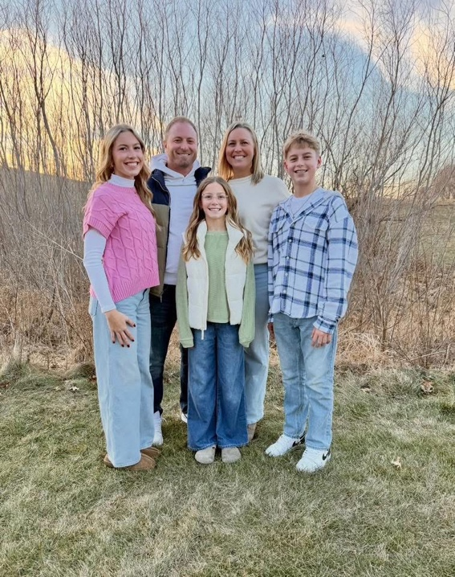

Andrew and Stephanie (Peiffer) Hoopes ‘02
Met in 1998 at Simpson. Married in July 2002.
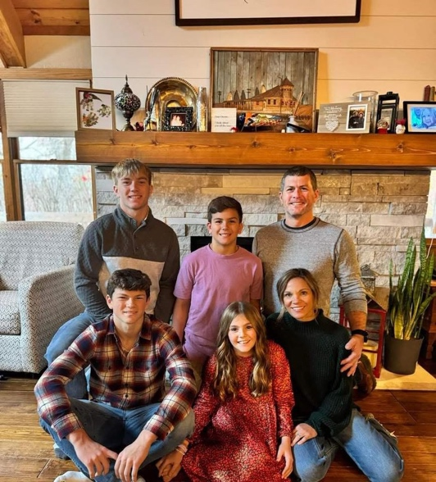
James and Lora Duncan Patton ‘92
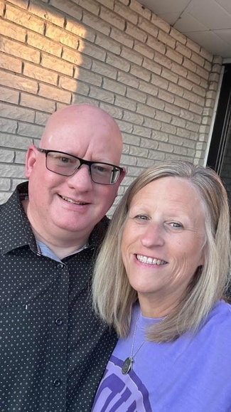

Dave and Kim Keller since 1978
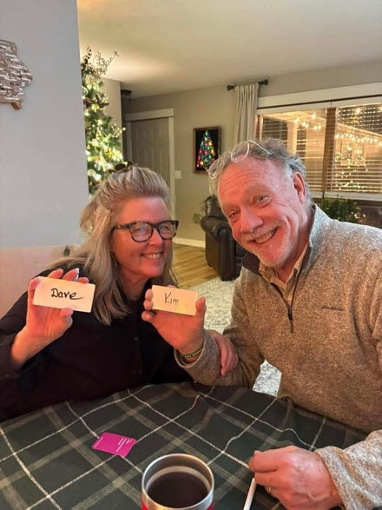

Andrea and Axel Foley '04
We will be married 21 years on 06/04/05
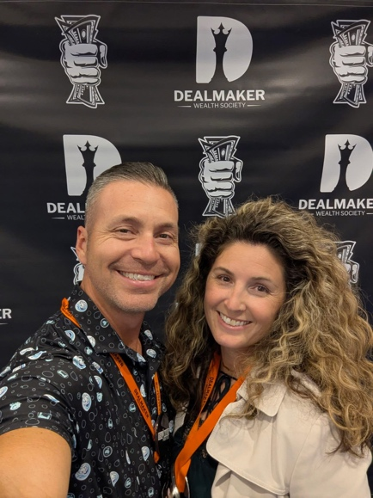
Kevin (‘97) and Tammy (‘98) (Keuning) Steenhoek
Married in 1999.
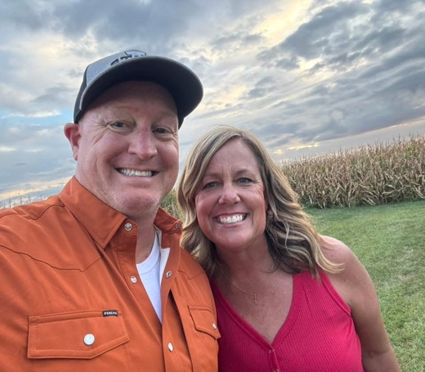

Gary ‘90 and Kamie Downing Haynes ‘92
Together 38+ years, married 33+. Pictured at a Pi Phi fall party in 1988 with our besties Christy Christenson Heller and Joe Heller.
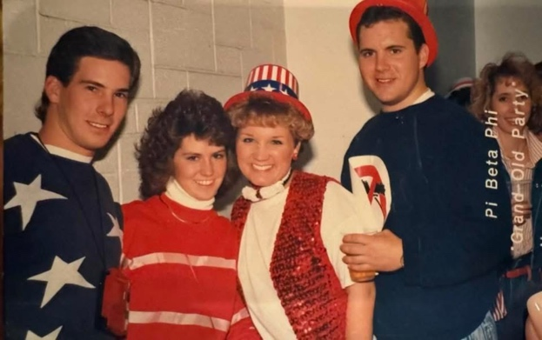

Alex '98 & Tina '95
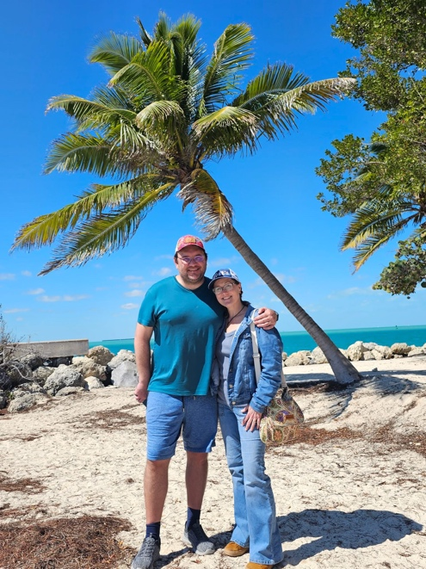

Joey and Carlie (Beals) Hajduch ‘08
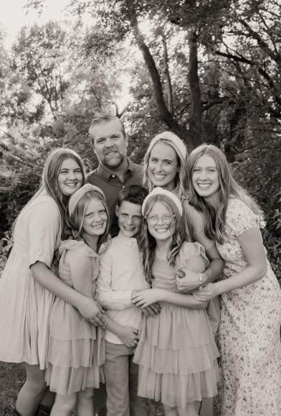

Ryan Runyan ‘12 and Stephanie Vampola-Runyan ‘10
Met in 2008 in Lekburg at Simpson and Married in 2018!
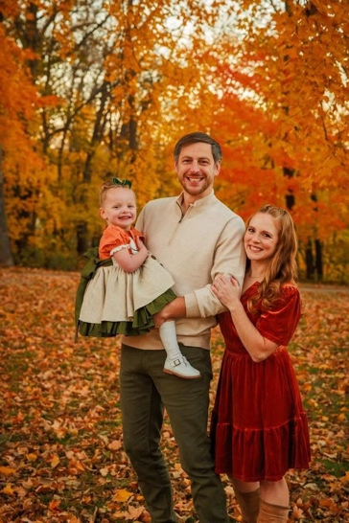

Dylan and Jill Dinkla ‘12
Married in 2016.
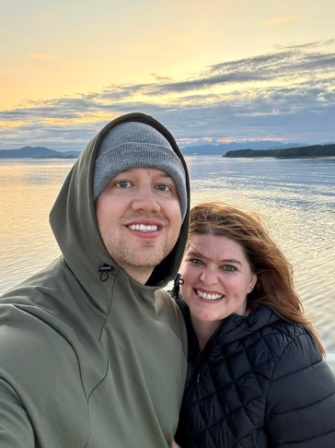
Danny ‘18 and Morgan Reetz ‘14
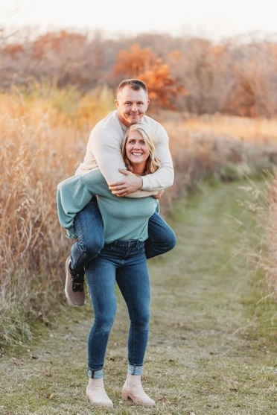

Christopher Hanson ’18 and Addison Hanson '19
Been together since 2017 and got married in 2022.
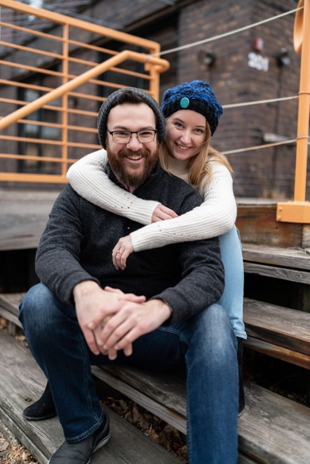

Tom '94 and Marcy '98 Roff
Met 1993 at Simpson, married at Smith Chapel August 1997.
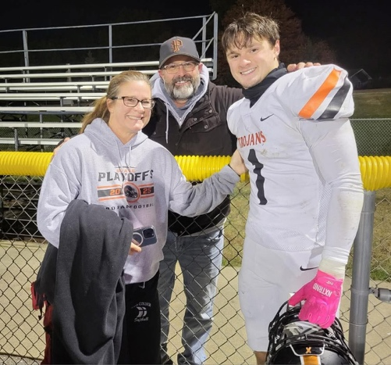

Spencer Moon and Elie Tuhn
Getting married this summer!
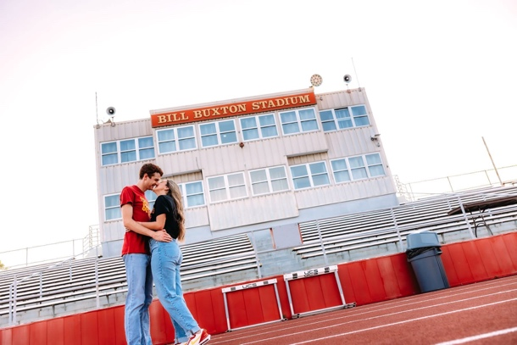

Alex ‘07 and Heather ‘10
We have been together for 20 years, married for 13.
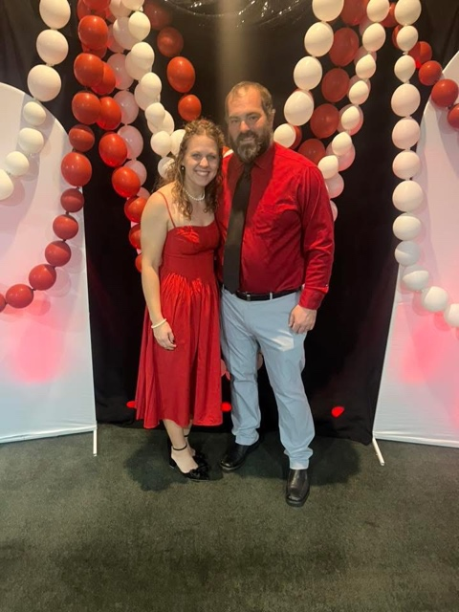

Kim Nolting Johnk ‘85 & Mitch Johnk 86’ Married 7/12/86.
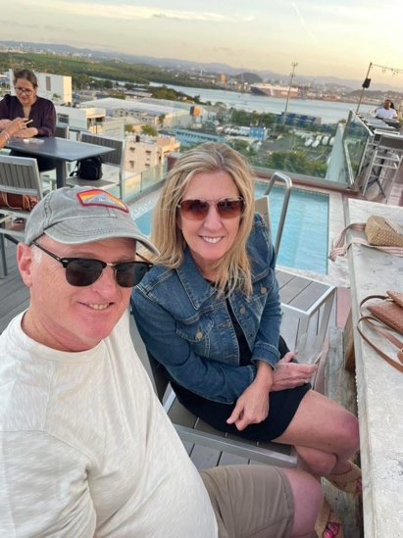

Mike Butler ’89 and Jolene Erickson Butler ‘92
Married 31 years.
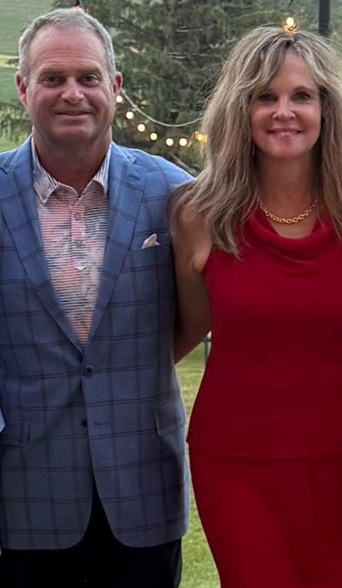

Gary and Jeanne Noble
Married in Smith Chapel on June 1st, 1974.
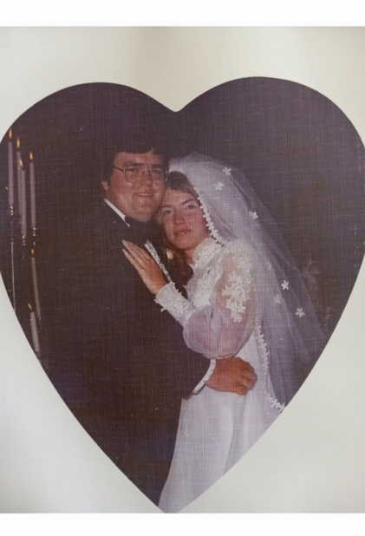
Rick and Karen Carlson Gilson ‘84
Married 42 years this June!
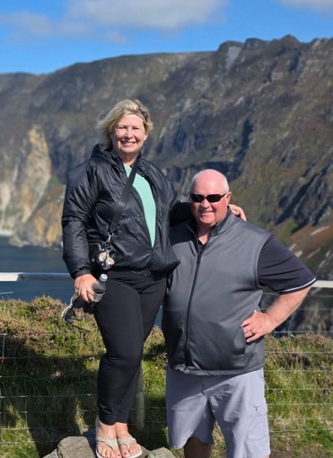
Cortez ‘18 and Annemarie Daniel '19
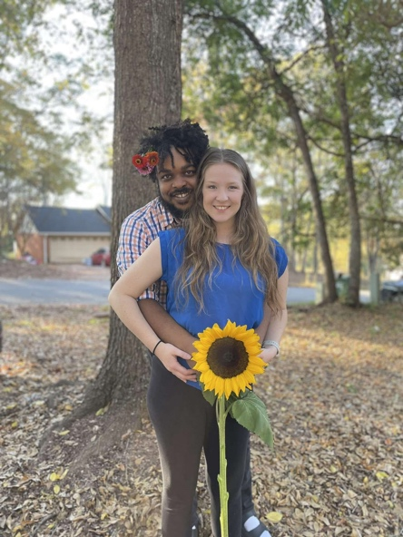

Marty Princehouse ’00 and Katie (Snyder) Princehouse ‘02
Married since 8/03/02.
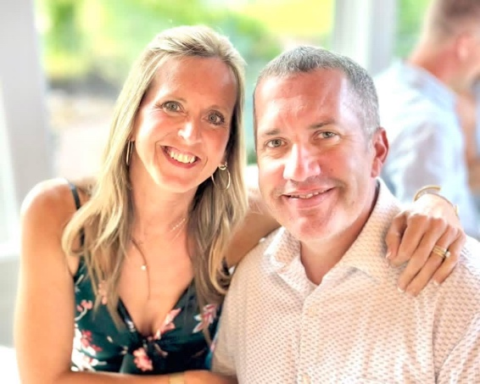

Mike Becker ‘92 & Deb (Hannover) Becker ‘93
Married 1994.
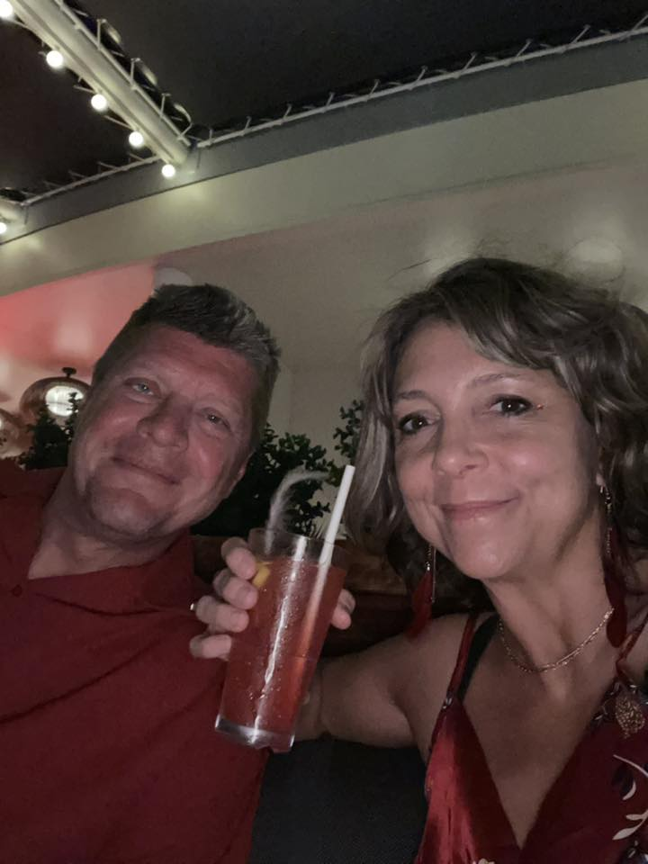
Darin ‘91 and Christy DeGoey ‘90
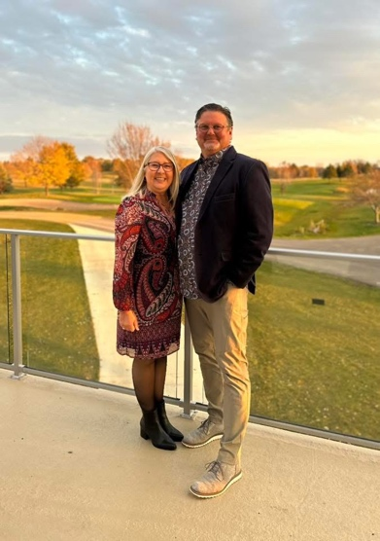

Barb Houghton Kohl and Dave Kohl ´70
Married 8/8/70. We travel and have fun with other Simpson Sweethearts: Roger and Shari Winslow Thompson, Keith and Sue Schmitz and Carl and Dania Weaver Kinney.
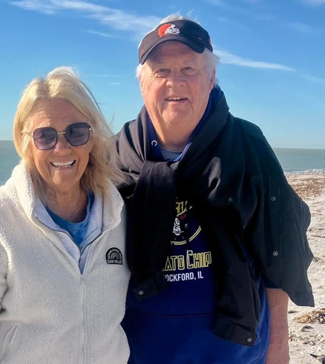

Grant ‘13 and Kaylee Focht ‘15
Married 9 years and together 14!
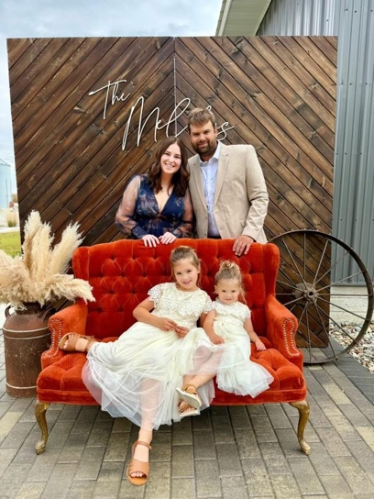
Hannah Landgraf ‘12 and Eric Rucker (Director of the Simpson Youth Academy)
Not a traditional Simpson Sweetheart story, but worth sharing. Hannah used Eric’s current office when she was the RLC president in 2011. She met Eric in seminary and convinced him to apply for a job at her beloved alma mater and return to Iowa with her.
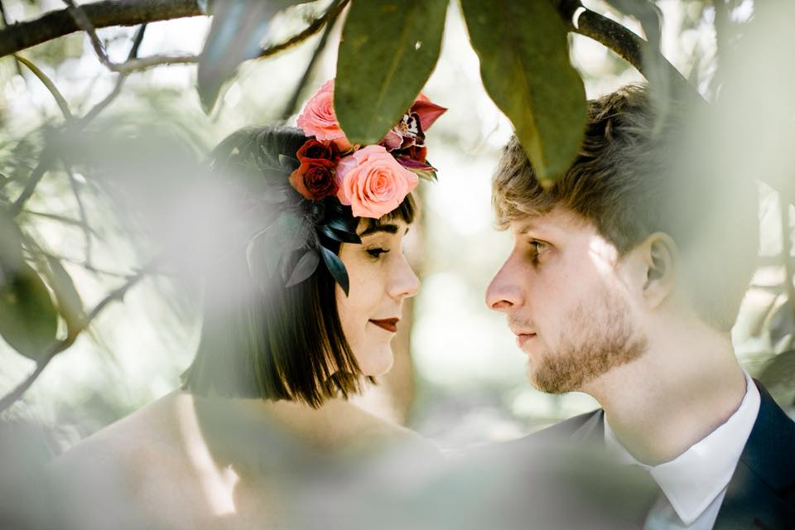

Seth and Emily Keller Lampman
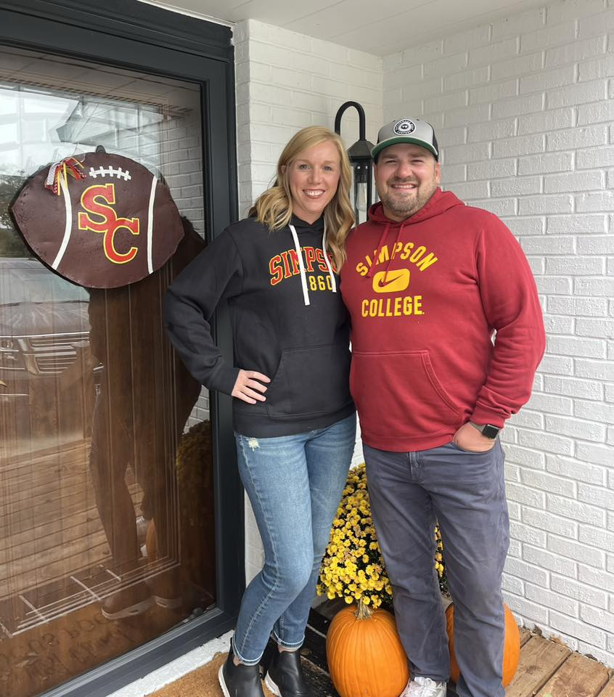

Joe ‘82 and Kathy Nahkunst Bell ‘81
Together since 1979 and Married since 1982.
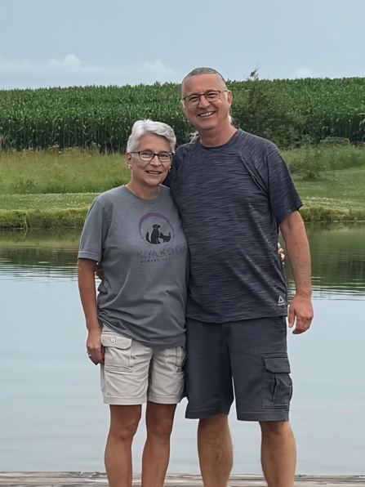
Nathaniel Hedin Schmidt '09 and Elizabeth Carr '06
Started dating fall of '05, married at Smith Chapel in Sept of '09.
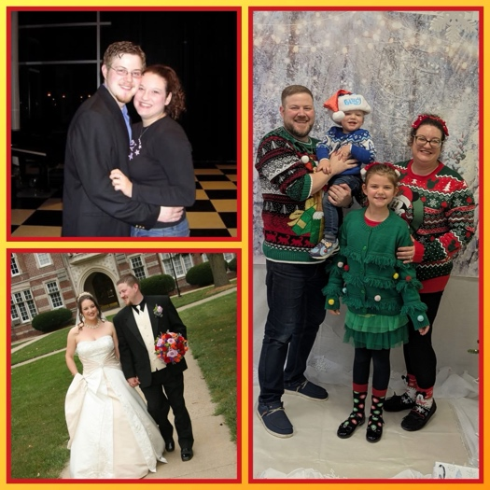

Brad and Pagie Warren
Married 34 years. Two children and 1 grandchild. Retired this spring from public education.
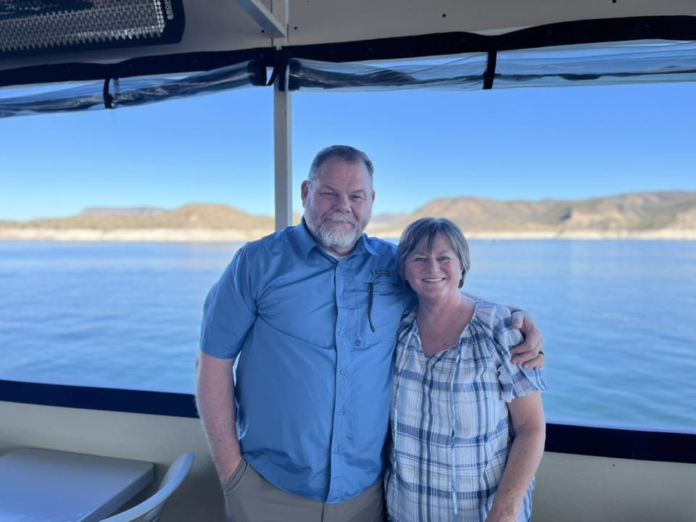

Chad and Hillary Prall ‘94
Started dating Junior year. Married 31 years.
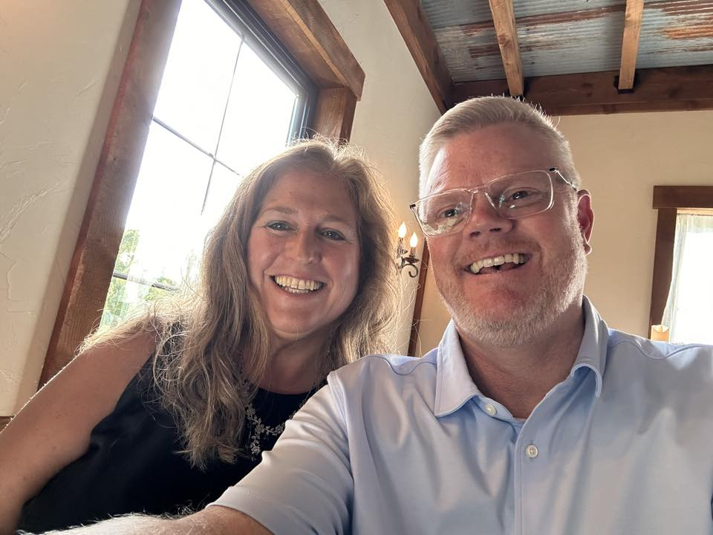

Casey and Margery (Hanes) Pierce ‘99
Married 2002.
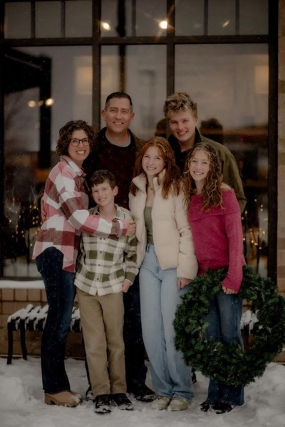

Christine and Cody Ries
Married 17 years this Valentine’s Day!
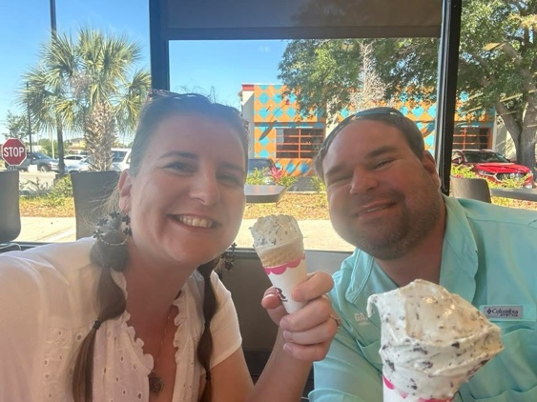

Eric ‘07 and Sadie Zisoff ‘09
Together 20 years & married for 15 years this December.
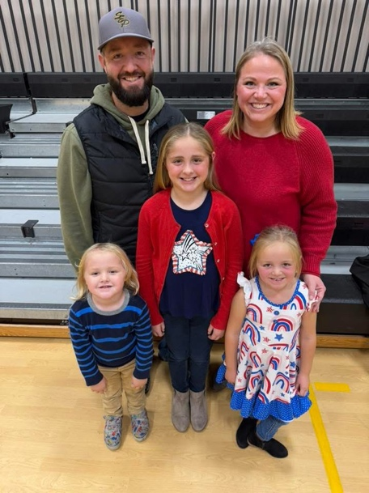
Michael and Jenn O'Tool '92
Met fall of '88 in Pfeiffer Dining Hall. Married in April 1998.
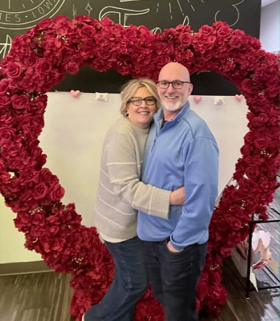

Trena and Dainel McCraine
We meet Feb 6th... 33 years ago... And have been married 30 years.
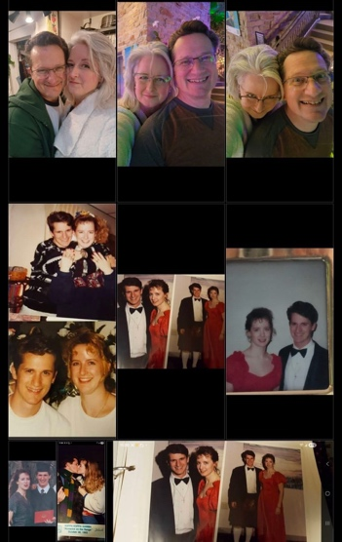

Joel Clifton ’89 and Rochelle (Duensing) Clifton ‘90
Married 9/29/90 at Smith Chapel. 35 years of nonstop adventures!
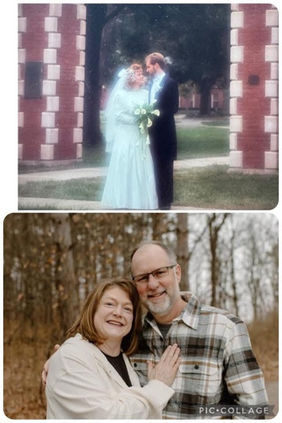
Ulices Flores ’16 and Yaritza Chicas ‘17
Together for 11 years. Engaged for 2 years.
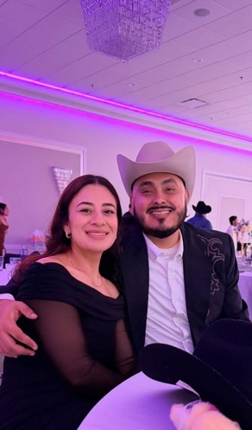

Kelly and David Doherty ‘87
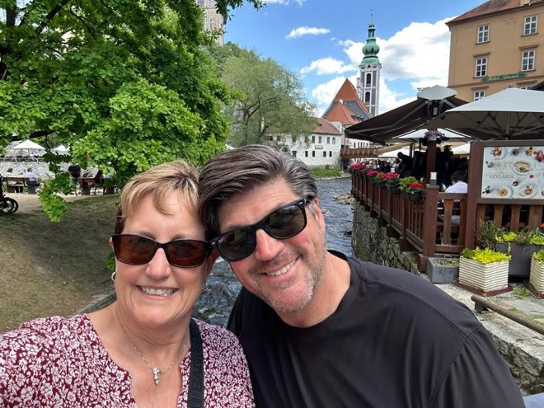

Ken ‘77 and Sherry (Johnson) Cunningham ‘76
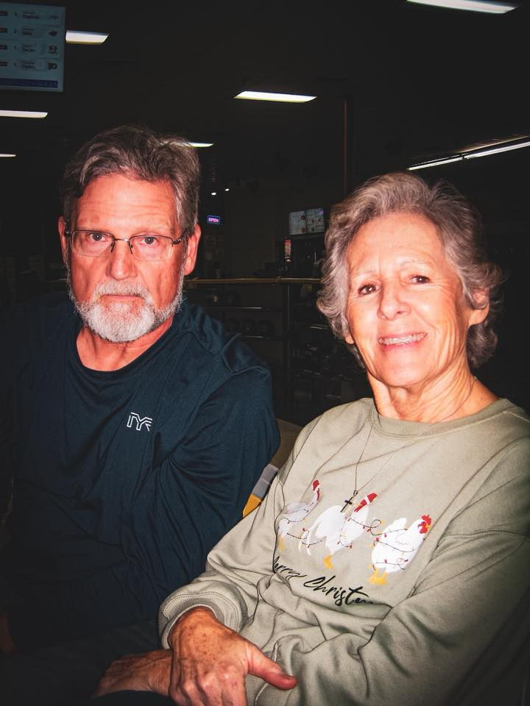

Dillon and Lindsey McKelvey ‘09
Together 23 years, married for 17 years this August.
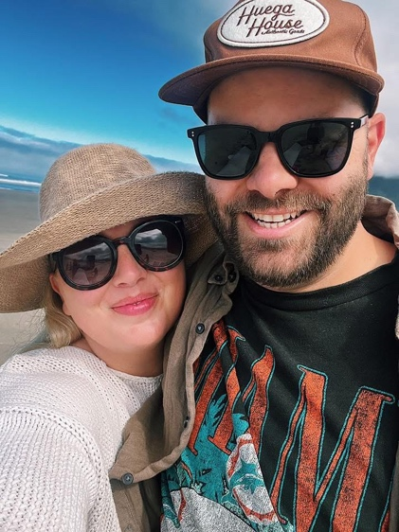

Joe and Christy Heller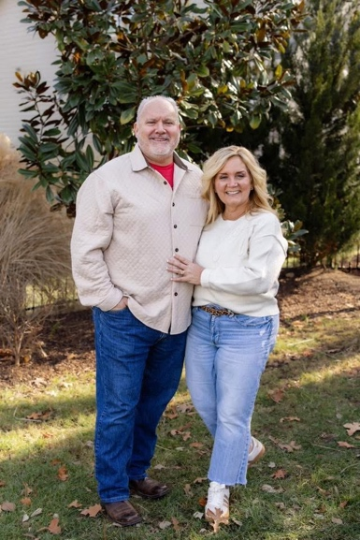

Seth '17 and Courtney Albers '15
Met at Simpson in 2015. Married in 2019. Now we have two beautiful girls!
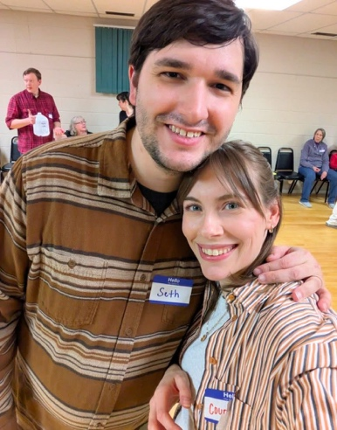
Madelynn and Jake Gibney ‘18
Together since 2014, married 2018.
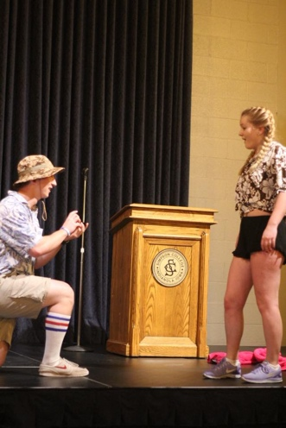

Harold Crow ATO and Florence Sanderson Crow Pi Phi
Married 1951. All 3 children graduated from Simpson. Mom's sister and Dad's brother graduated from Simpson as well as a brother-in-law and nephew.
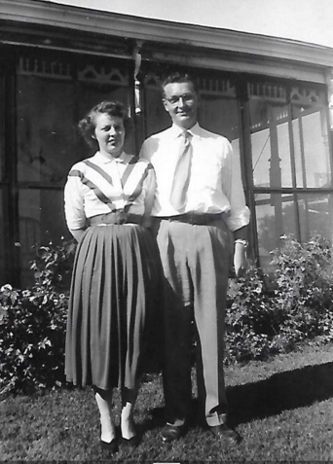

Madison and Josh Paulson ‘20
Together since 2018 and married since May 2025!
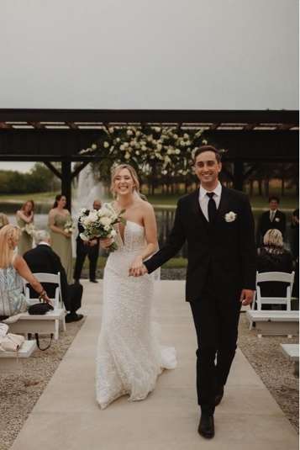
Christopher ‘87 and Jill Bemis ‘89
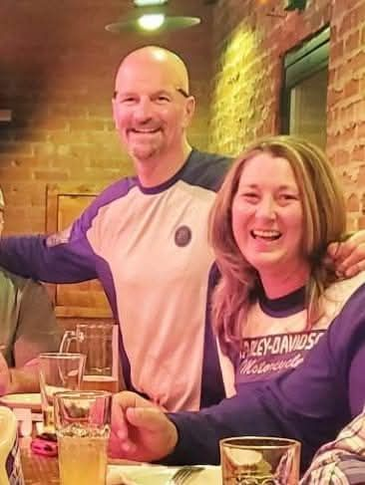

Andy Hansen ’08 and Darrin (Gregory) Hansen ‘07
Married 15 years this fall
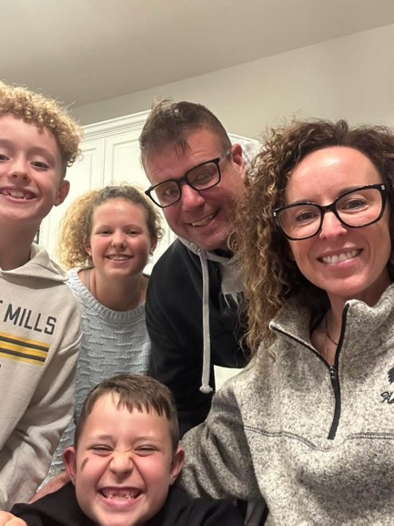

Chuck and Linda
Married 57 years!
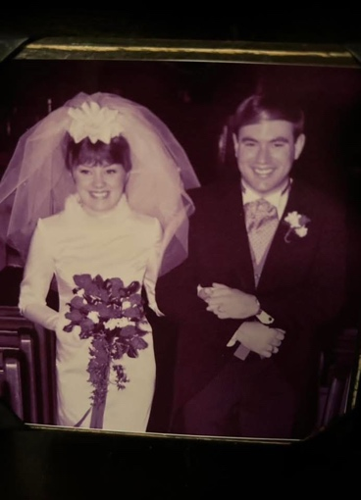
Cory Darrington ‘05 and Abby Janssen Darrington ‘06
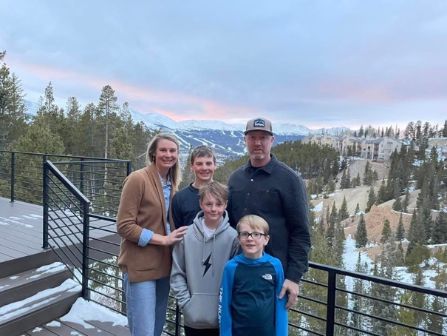

Anders and Jen (Gibson) Dovre ’07 Married Aug of 07
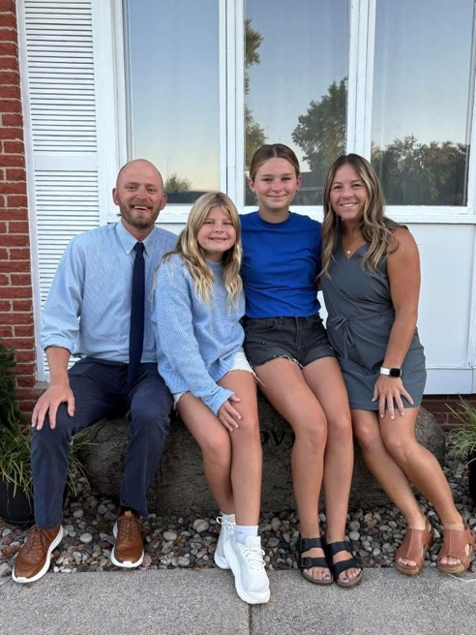

Joey and Rachel (Freland) Gale ‘19
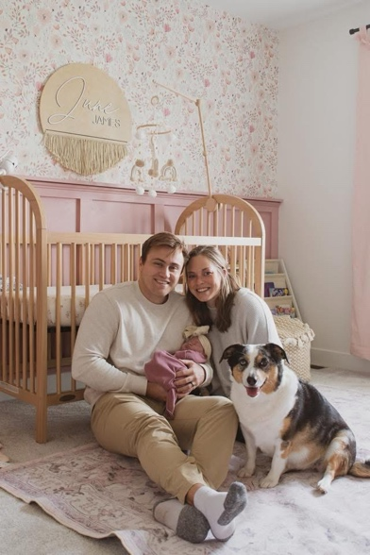
Kris Newman Geiger ’94 and Robb Geiger ‘96
Met on a London May Term trip in 1993. We will be married 30 years in July!
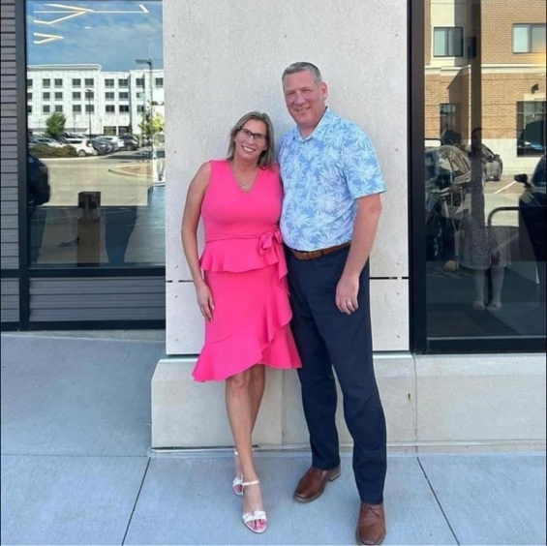

Corbin Truitt ‘25 and Elise Boulton ‘24
Getting married at Simpson in 2026!
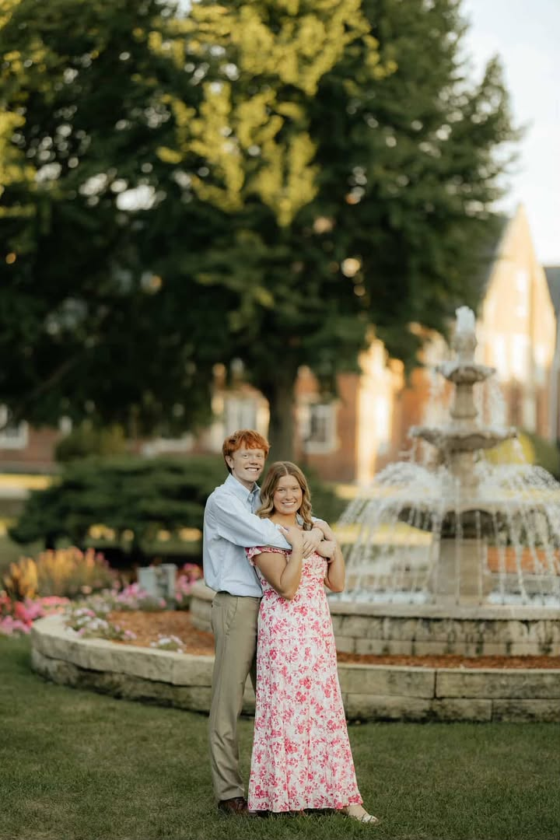

Melinda and Dennis Hendrickson
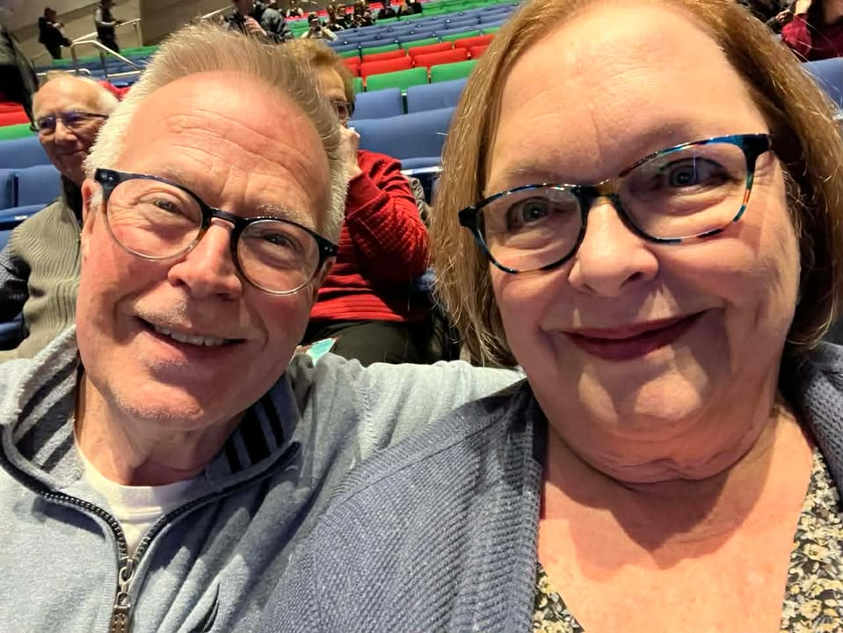
Alex Vander Veen and Tony Clinesmith ‘17
Together for 11 years
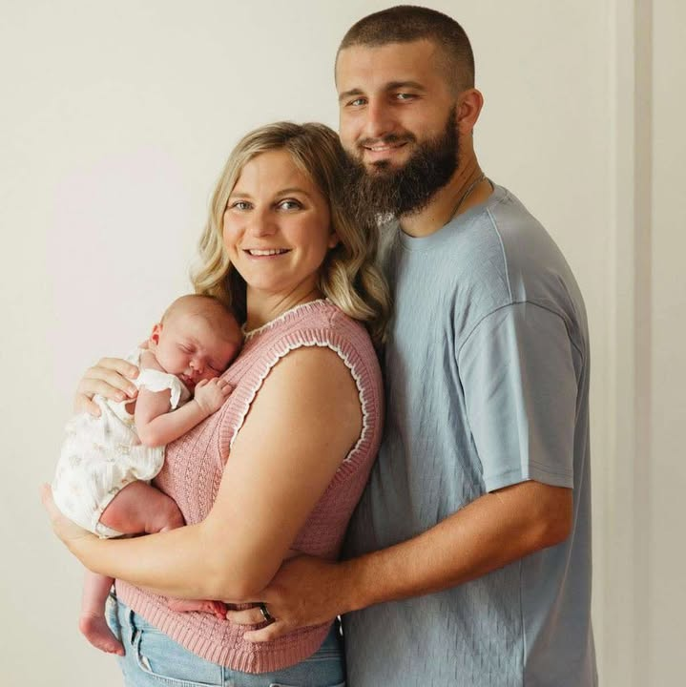

Bill and Lauren (Bucklin) Nelson
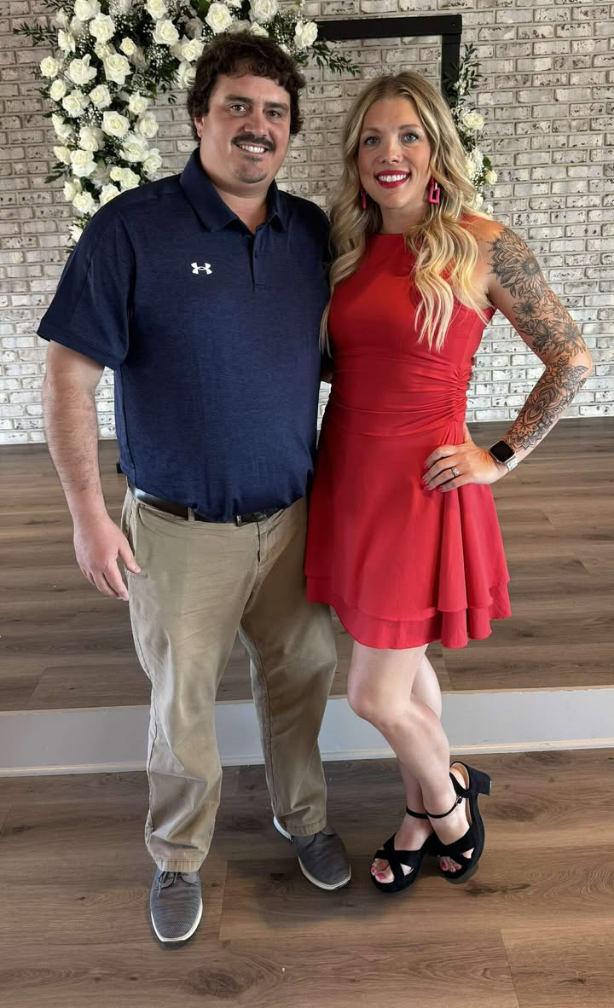

RJ Brown ‘19 and Kasiah (Ehresman) Brown ‘20
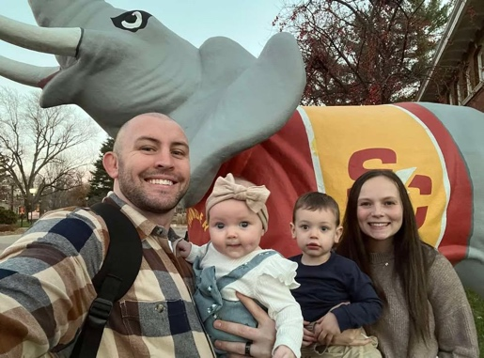
Brennen and Chaeli Moir Lemke ‘23
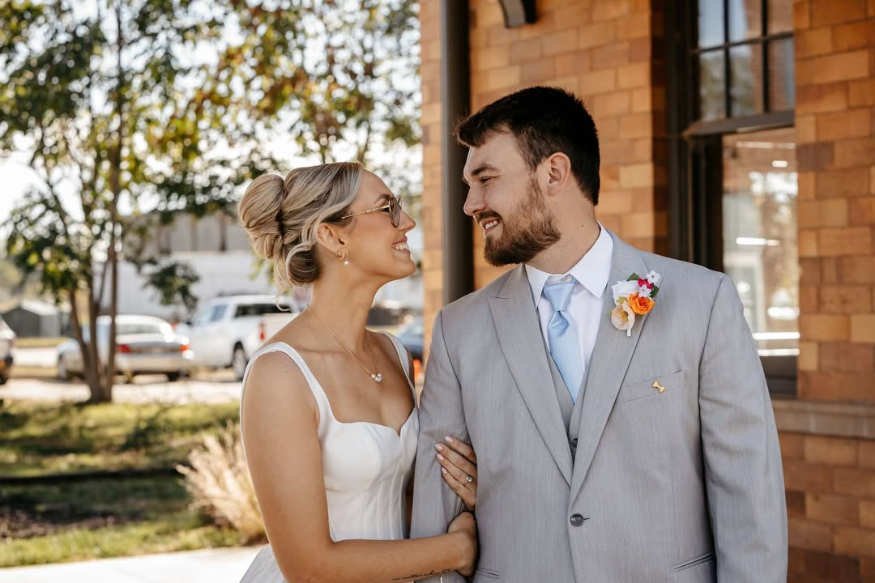

Adam and Madeline Reiter
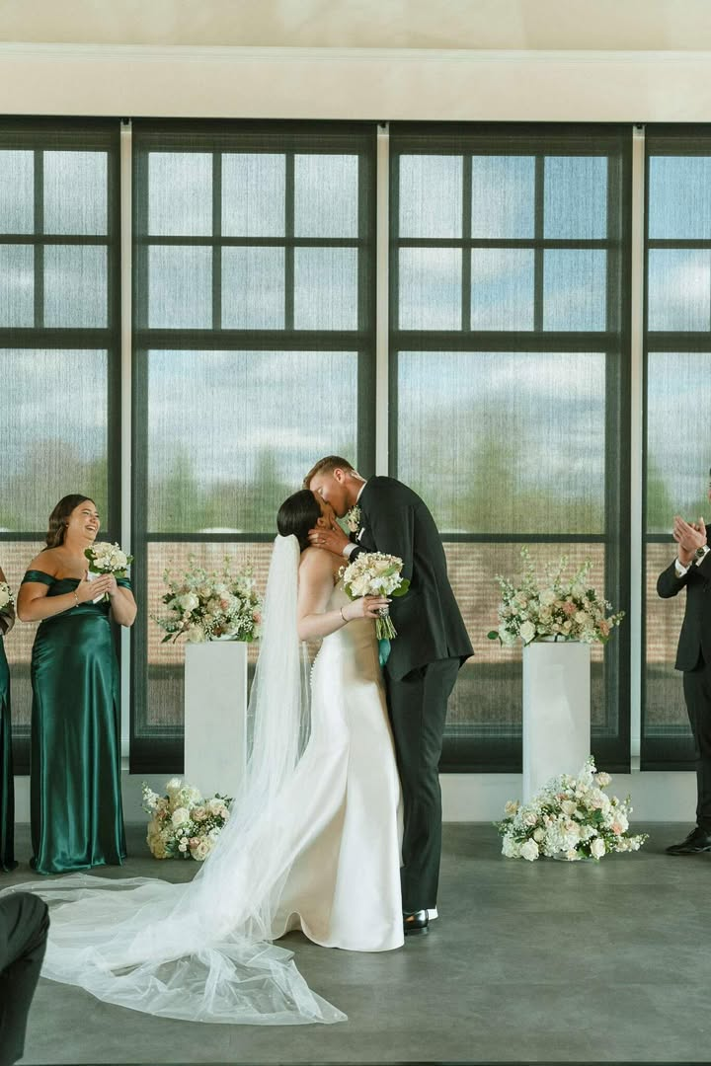

Ryan ’99 and Kristi Carpenter ‘00
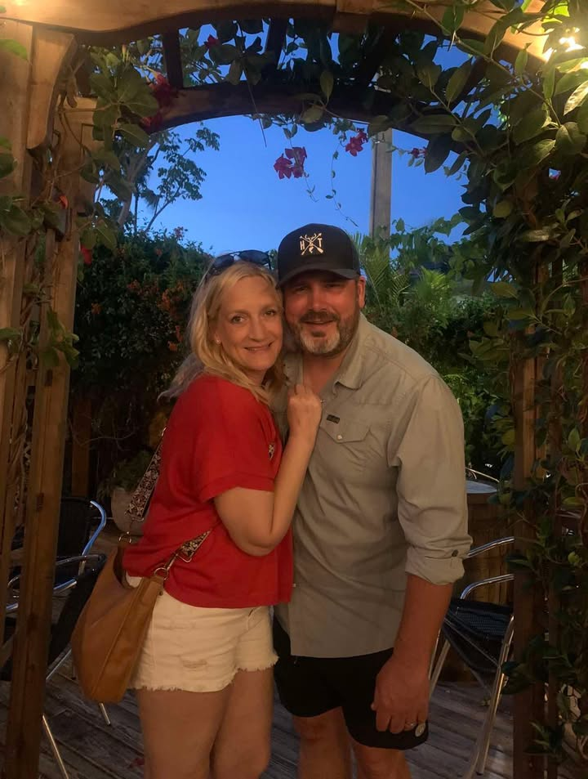
Mandy Pitzen
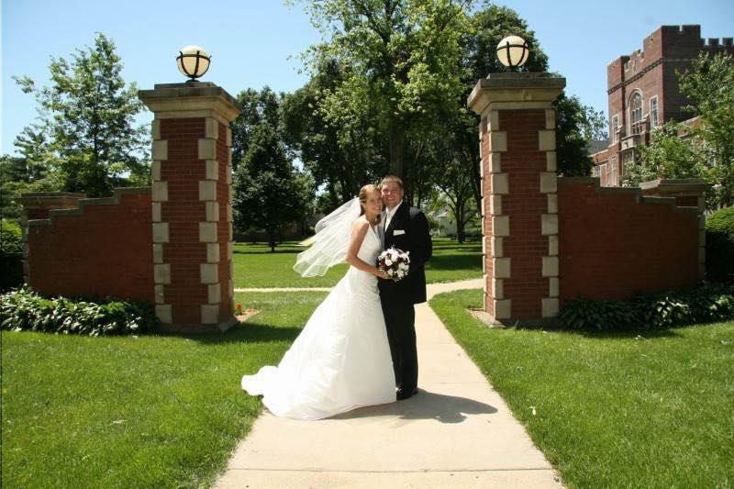

Zach Rus and Beth Shelton
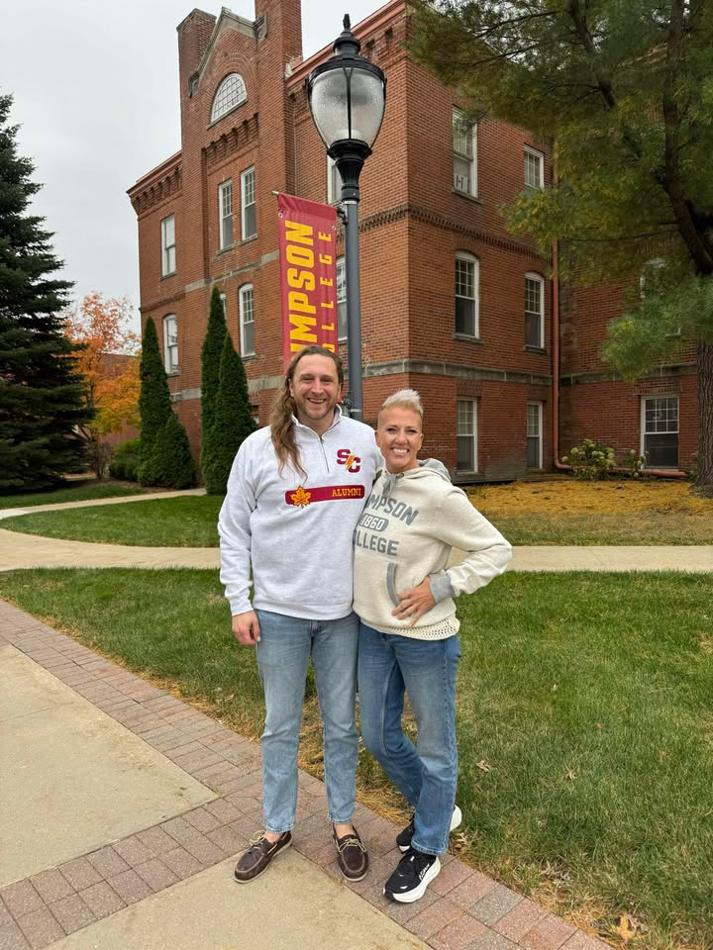

Emma Winterboer and Chance Gibbons
